

FUNDRAISING

**\*\*\*\*\*\*\*\*\*\*\*\*\*\*\*\*\*\*\*\*\*\*\***

WIN fantastic prizes with our

ONLY 50p a tickets OR £2 for a line!!

**\*\*\*\*\*\*\*\*\*\*\*\*\*\*\*\*\*\*\*\*\*\*\***

DONATE NOW to see staff dye their hair!

Raise £50 to see Diane’s hair RED

£70 to see Kendra’s hair GREEN

£100 to see Judith’s hair SILVER

£150 to see Sam’s hair all 3 colours!

*All fundraising in aid of Strongbones.*

Start the New Year with new qualifications!

Level 3 Diploma for Early Years Workforce

With this course you will complete:

* + Diploma for Early Years Workforce
  + Functional Skills ICT Level 2
  + 12 hour paediatric First Aid Level 3
  + ERR Unit
  + Be Safe Booklet

The course takes 12-18 months to complete and includes written work, observations and each month 2 days/evenings in college.

*To be eligible you MUST:*

* *have a GCSE Grade C or above in English and Maths or O Level Level 1*
* *be employed at least 30 hours per week in a workplace*

**November 2014**

**Newsletter**



**CHOCOLATES**

***Gives you knowledge of children aged 0-7 years***

50p a guess

**Special offer**

**NO** Top-up fee for the

Level 3 Apprenticeship

until 16th December 14

(Only eligible if you do not hold a Level 4 qualification or above)



***Qualifies you to work with children aged 0-5 years***

***STAFF TO DYE***

***HAIR FOR CHARITY!***



Eden Training Ltd encourages learners attending college to join in with our regular fundraising events!

In May 2014 we raised £80 for Strongbones by holding a raffle. Prizes included Thornton’s chocolates, I-pod shuffle and an Odeon voucher.

So far this year we have donated £195 to Strongbones!

Eden Training Ltd

178-180 Pall Mall

Leigh-on-Sea

Essex

SS9 1RB

Tel: 01702 680068

[info@edentraining.co.uk](mailto:info@edentraining.co.uk)

www.edentraining.co.uk

**16-18 years old??**

*It’s not too late to start training with us*

*– we recruit and have inductions each month!*

Join us NOW to gain a qualification in any of the following areas:

Level 1 Introduction to Early Years (Classroom based)

Level 2 Introduction to Early Years Education and Care (Classroom based)

Level 2 Certificate for the Children and Young People’s Workforce (Apprenticeship)

If you are 19+ these co-funded courses could be PERFECT for you!

Level 2 Certificate for the Children and Young People’s Workforce

Level 3 Diploma for Early Years Workforce

*The following funding options are available for learners aged 19+*

**Apprenticeship aged 19-23 years –** SPECIAL OFFER - No top-up fee to pay until 16th December 2014!

**Apprenticeship aged 24+ -** Pay a top-up of £200 for the course and £30 for e-portfolio registration and text book.

*Eligible for co-funding if working 30 hours a week and do not have a Level 4 qualification or above.*

**Collaborative funding 19+** - Level 2 Pay a top-up of £200 for the course and £30 for e-portfolio registration and text book. *Must work a minimum of 6 hours a week and not hold a qualification any higher than a Level 4.*

**24+ Advanced Learning Loan** – The loan covers the cost of the course. *Don’t pay anything back until 2016 and then only if you earn over £21,000 per year. Wiped clean after 30 years! Doesn’t affect your credit rating or take into account your house hold income.*



Any training you would like us to put on for you? Drop us an email and let us know! judith@edentraining.co.uk





Safeguarding

*£60 for 10-2pm workshop. CACHE registration and certificate*

CYPOP5

*£169 for 8-12 week course.Online course or can be done in small groups over 3 months*

12 hour Paediatric First Aid Level 3

*£60 for two 6 hour sessions*

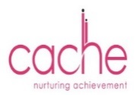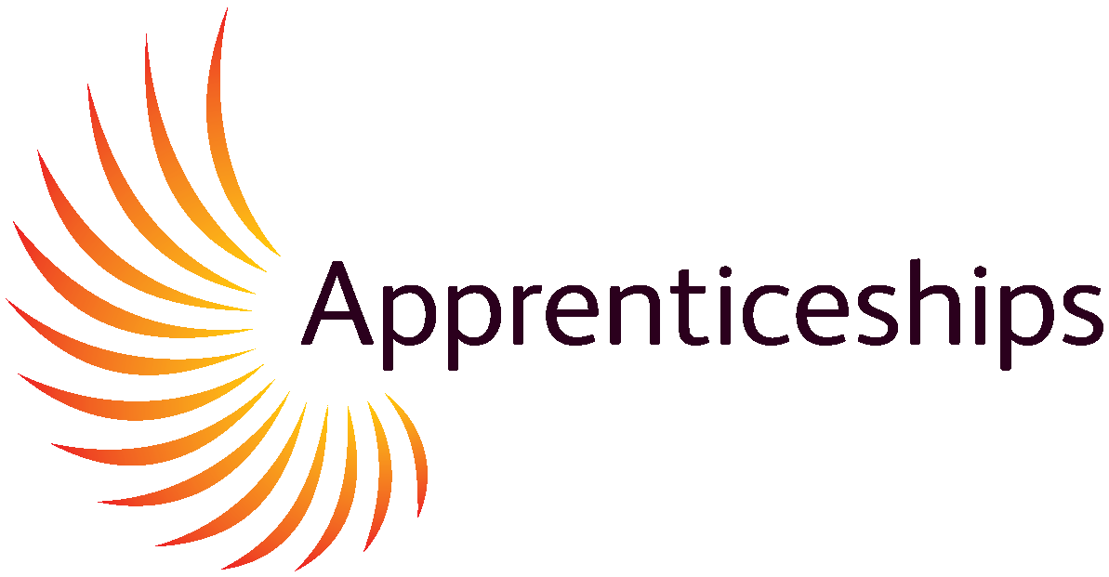[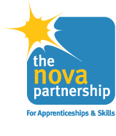](http://www.nova.org.uk/Default.aspx)